Updates to the server systems
By Haydn Roberts
This is the previous database ERD, it had good overall logic but is missing a lot of required features, this document contains the reasoning for the changes I have made to the database, with SQL for each table as SQL contains all of the data in an ERD except the join relations(one to one, many to many…) and these will not be suited for showing an individual table so will instead be discussed at the end.
Original database ERD:
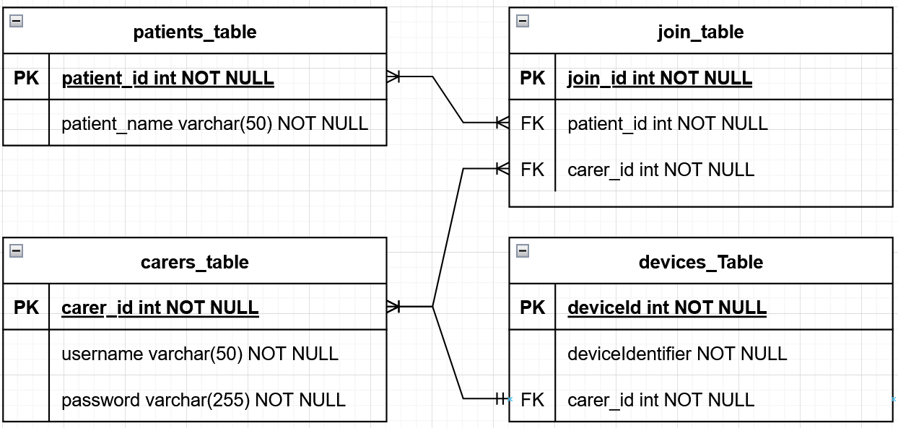
The original database design successfully modelled the core domain relationships of the system:
- carers ↔ patients (many-to-many)
- patients ↔ devices (one-to-many)
However, it lacked several features that became mandatory after stakeholder discussion and security analysis:
- Multiple user types require login
  - carers
  - patients
  - administrators
- Geofencing data must be stored persistently
- Security risks identified in the CIA and AAA analyses must be mitigated at the data layer
- Authentication data must be separated from domain data
From a security engineering perspective, the original approach of storing username and password directly in the carer table violated multiple modern security principles: OWASP: Identification and Authentication Failures, AAA: Authentication vs Authorization separation, CIA: Confidentiality of credentials.
So, the most secure method will be to create an account table where login information and roles are stored and then use this as a foreign key on the patients and carers table.
Why this matters:
- One login system supports all user types
- Role-based access control (RBAC) becomes enforceable
- Admin privileges are isolated and auditable
This directly supports the AAA model:
- Authentication → account exists
- Authorization → role defines permissions
- Accounting → actions can be logged per account
Here is the Sql for this new table:
account (
account_id UUID PRIMARY KEY,
email VARCHAR(255) UNIQUE NOT NULL,
role VARCHAR(30) NOT NULL,
is_active BOOLEAN DEFAULT true,
created_at TIMESTAMP NOT NULL
);
Based on the report made by James, a separate authentication table with the password hash and salt will be a secure way to store passwords for our application and contains additional columns to be added for Multi-Factor Authentication if adding this is within the scope of the projects’ future development but for now will all be marked as false.
account_auth (
account_id UUID PRIMARY KEY REFERENCES account(account_id),
password_hash BYTEA NOT NULL,
password_salt BYTEA NOT NULL,
mfa_enabled BOOLEAN DEFAULT false,
mfa_secret BYTEA,
last_login TIMESTAMP
);
The carers and patient tables must also be changed to accommodate these new tables:
carer (
carer_id UUID PRIMARY KEY,
account_id UUID UNIQUE REFERENCES account(account_id),
name VARCHAR(100)
);
patient (
patient_id UUID PRIMARY KEY,
account_id UUID UNIQUE REFERENCES account(account_id),
name VARCHAR(100),
);
Now that the login logic has been updated, we can discuss the need for a table to store the geofence information of the routes and locations that patients are safe to be in.
This section was greatly helped by Daniel’s research into geofencing methods document.
To uphold our security standards and abide by James’ report, we need to Encrypt Geofence Data in the Database, as seen in the report: “If location data is stored in plaintext … attackers could fully reconstruct movement patterns.”
To combat this: coordinates must not be readable at rest and the application encrypts geofence geometry before storage.
A valid method to achieve this is the column encrypted_payload (AES-256-GCM).
What is encrypted?
- circle centre + radius
- polygon vertex lists
- tolerance thresholds
Why encrypt at application level?
- Database compromise ≠ data compromise
- Encryption keys remain outside the DB
This prevents attackers from modifying coordinates directly or injecting malformed geometry.
Daniel’s geofencing research labelled two main geometry types for our geofencing, Circular and Polygon. The database will store a shape_type, allowing for both options as we plan to implement circular geofencing first to achieve a minimum viable product and then add the polygon geofencing to allow carers to draw out the routes that their patient will be safe within. Timestamps are supplied by the application or generated using NOW().
CREATE TABLE geofence (
geofence_id UUID PRIMARY KEY,
patient_id UUID REFERENCES patient(patient_id) NOT NULL,
name VARCHAR(100),
shape_type VARCHAR(20),
encrypted_payload BYTEA NOT NULL,
is_active BOOLEAN DEFAULT true,
created_at TIMESTAMP NOT NULL,
created_by UUID REFERENCES account(account_id) NOT NULL
);
The I in CIA security triad stands for Integrity, and the geofencing logic is a great place to implement this, as geofence’s are likely to be changed (a house extension could lead to the radius being expanded or a building site could lead to a rerouted path to the local shop) so an audit log will be handy to stop insider threats or silent tampering (for example: a negligent carer changing the radius of a geofence to be larger than is safe.) This will also be needed to settle disputes from caregivers as every change to the geofence will be logged.
This means that this table will have to record: Who changed the geofence, When it was changed, Why it was changed and What change occurred.
Deciding on how to display what change occurred was very difficult as a before and after leads to a much larger attack surface, increases data retention of sensitive information and creates a long term privacy exposure if the attacker can get through the encryption. Because of this I opted to only implement a text column with CREATE, UPDATE, DELETE, ACTIVATE, DEACTIVATE as the text, this describes What change happened to the related geofence.
Here is the audit table:
CREATE TABLE geofence_audit (
audit_id UUID PRIMARY KEY,
geofence_id UUID REFERENCES geofence(geofence_id),
action VARCHAR(20) NOT NULL,
performed_by UUID REFERENCES account(account_id),
performed_at TIMESTAMP NOT NULL,
reason TEXT
);
I have updated the device table to be able to handle hardware-backed identities, signed messages and replay-attack prevention, this was achieved by adding device identifiers, public keys and provisioning timestamps.
CREATE TABLE device (
device_id UUID PRIMARY KEY,
patient_id UUID REFERENCES patient(patient_id),
device_identifier VARCHAR(100) UNIQUE,
public_key BYTEA,
is_active BOOLEAN DEFAULT true,
provisioned_at TIMESTAMP
);
The website will be using sessions to keep the user logged in as they navigate pages, so sessions are required. To reinforce session security, a sessions table can be useful to support: shorter lived login sessions, forced logout and a response to compromised accounts. This mitigated stolen cookies, forms of session hijacking and account lockout abuse which are all serious security concerns.
CREATE TABLE session (
session_id UUID PRIMARY KEY,
account_id UUID REFERENCES account(account_id),
issued_at TIMESTAMP NOT NULL,
expires_at TIMESTAMP NOT NULL,
revoked BOOLEAN DEFAULT false
);

Here is the full SQL for adding tables to the database:
CREATE TABLE account (
account_id UUID PRIMARY KEY,
email VARCHAR(255) UNIQUE NOT NULL,
role VARCHAR(30) NOT NULL,
is_active BOOLEAN DEFAULT true,
created_at TIMESTAMP NOT NULL
);
CREATE TABLE account_auth (
account_id UUID PRIMARY KEY REFERENCES account(account_id),
password_hash BYTEA NOT NULL,
password_salt BYTEA NOT NULL,
mfa_enabled BOOLEAN DEFAULT false,
mfa_secret BYTEA,
last_login TIMESTAMP
);
CREATE TABLE patient (
patient_id UUID PRIMARY KEY,
account_id UUID UNIQUE REFERENCES account(account_id),
name VARCHAR(100)
);
CREATE TABLE carer (
carer_id UUID PRIMARY KEY,
account_id UUID UNIQUE REFERENCES account(account_id),
name VARCHAR(100)
);
CREATE TABLE carer_patient (
id UUID PRIMARY KEY,
carer_id UUID REFERENCES carer(carer_id),
patient_id UUID REFERENCES patient(patient_id)
);
CREATE TABLE device (
device_id UUID PRIMARY KEY,
patient_id UUID REFERENCES patient(patient_id),
device_identifier VARCHAR(100) UNIQUE,
public_key BYTEA,
is_active BOOLEAN DEFAULT true,
provisioned_at TIMESTAMP
);
CREATE TABLE geofence (
geofence_id UUID PRIMARY KEY,
patient_id UUID REFERENCES patient(patient_id) NOT NULL,
name VARCHAR(100),
shape_type VARCHAR(20),
encrypted_payload BYTEA NOT NULL,
is_active BOOLEAN DEFAULT true,
created_at TIMESTAMP NOT NULL,
created_by UUID REFERENCES account(account_id) NOT NULL
);
CREATE TABLE geofence_audit (
audit_id UUID PRIMARY KEY,
geofence_id UUID REFERENCES geofence(geofence_id),
action VARCHAR(20) NOT NULL,
performed_by UUID REFERENCES account(account_id),
performed_at TIMESTAMP NOT NULL,
reason TEXT
);
CREATE TABLE session (
session_id UUID PRIMARY KEY,
account_id UUID REFERENCES account(account_id),
issued_at TIMESTAMP NOT NULL,
expires_at TIMESTAMP NOT NULL,
revoked BOOLEAN DEFAULT false
);
Adding stored procedures will lead to less SQL or sensitive logic being exposed in the source code and such, will help this system become more secure.
It is important to note that these procedures will not hash or verify passwords as all cryptography should happen in the application layer.
This means that before the create_account procedure is called, the user must submit their password, the application must generate salt and hash the password, and then send the email, role, password_hash and salt to the database, then the procedure can be called:
CREATE OR REPLACE PROCEDURE create_account(
p_email VARCHAR,
p_role VARCHAR,
p_password_hash BYTEA,
p_password_salt BYTEA
)
LANGUAGE plpgsql
AS $$
DECLARE
v_account_id UUID := gen_random_uuid();
BEGIN
-- Create identity
INSERT INTO account (
account_id,
email,
role,
is_active,
created_at
)
VALUES (
v_account_id,
p_email,
p_role,
true,
NOW()
);
-- Store authentication material
INSERT INTO account_auth (
account_id,
password_hash,
password_salt,
mfa_enabled
)
VALUES (
v_account_id,
p_password_hash,
p_password_salt,
false
);
END;
$$;
This method of account creation inserts identity and authentication data in a single operation, preventing partial account creation and reducing SQL injection risk by eliminating dynamically constructed queries in application code, therefore making the system more secure.
The next useful procedures are for log in:
CREATE OR REPLACE FUNCTION get_auth_data_for_login(
p_email VARCHAR
)
RETURNS TABLE (
account_id UUID,
password_hash BYTEA,
password_salt BYTEA,
mfa_enabled BOOLEAN,
role VARCHAR,
is_active BOOLEAN
)
LANGUAGE plpgsql
AS $$
BEGIN
RETURN QUERY
SELECT
a.account_id,
aa.password_hash,
aa.password_salt,
aa.mfa_enabled,
a.role,
a.is_active
FROM account a
JOIN account_auth aa ON a.account_id = aa.account_id
WHERE a.email = p_email;
END;
$$;
After this is called, the application layer should check is_active, recompute the hash and then compare the hash to validate the password so that the session can be created. Sessions now have a database table so here is the session creation procedure:
CREATE OR REPLACE PROCEDURE create_session(
p_account_id UUID,
p_expires_at TIMESTAMP
)
LANGUAGE plpgsql
AS $$
BEGIN
INSERT INTO session (
session_id,
account_id,
issued_at,
expires_at,
revoked
)
VALUES (
gen_random_uuid(),
p_account_id,
NOW(),
p_expires_at,
false
);
UPDATE account_auth
SET last_login = NOW()
WHERE account_id = p_account_id;
END;
$$;
As well as procedures, we can use triggers to guarantee logging, enforce integrity and create a method of auditing that cannot be bypassed by application bugs.
Here is the SQL for the geofence audit function:
CREATE OR REPLACE FUNCTION audit_geofence_changes()
RETURNS TRIGGER
LANGUAGE plpgsql
AS $$
BEGIN
IF TG_OP = 'INSERT' THEN
INSERT INTO geofence_audit (
audit_id,
geofence_id,
action,
performed_by,
performed_at
)
VALUES (
gen_random_uuid(),
NEW.geofence_id,
'CREATE',
NEW.created_by,
NOW()
);
RETURN NEW;

ELSIF TG_OP = 'UPDATE' THEN
INSERT INTO geofence_audit (
audit_id,
geofence_id,
action,
performed_by,
performed_at
)
VALUES (
gen_random_uuid(),
NEW.geofence_id,
'UPDATE',
NEW.created_by,
NOW()
);
RETURN NEW;
ELSIF TG_OP = 'DELETE' THEN
INSERT INTO geofence_audit (
audit_id,
geofence_id,
action,
performed_by,
performed_at
)
VALUES (
gen_random_uuid(),
OLD.geofence_id,
'DELETE',
OLD.created_by,
NOW()
);
RETURN OLD;
END IF;
END;
$$;
And the trigger will be attached to the table with this SQL:
CREATE TRIGGER geofence_audit_trigger
AFTER INSERT OR UPDATE OR DELETE
ON geofence
FOR EACH ROW
EXECUTE FUNCTION audit_geofence_changes();
I also stated that I would include the relationships between tables so I have included them here at the end, these still stick to the logic of the original server systems document and so use the same justifications:
Account to Account authentication is one to one
Account to carer is one to one
Account to patient is one to one
Account to session is one to many
Carer to patient is many to many
Patient to device is one to many
Patient to geofence is one to many (this is for who the geofence applies to)
Account to geofence is one to many (this is for who created the geofence)
Geofence to geofence audit is one to many
Account to geofence audit is one to many

This is not the final draft for the database but I focused on making a secure system and it hopefully will not need too many changes after it has been reviewed by my teammates and our client. Thank you for reading though all of this, sorry for how long the document is.

